Wendy Shaw

776 words

**Society of Independent Painters and Sculptors (Müstakil Ressamlar ve Heykeltraşlar Birliği)**

Coming together for the first time with an exhibition in 1928 at the new Ankara Ethnographic Museum and establishing their name in 1929, the Society of Independent Painters and Sculptors was the first long-standing organization of artists working in the Republic of Turkey. Although their name, based on the French *La Societe des Artistes Independents*, indicated an oppositional stance to the dominant “academic” mode of painting in Turkey characterized in the work of the 1914 generation, the group advocated no unified political or aesthetic stance. Founding members included Refik Fazıl (Epikman; 1902-1974), Cevat Hamit (Dereli; 1900-1989), Şeref Kamil (Akdik; 1899-1972), Mahmud Celalledin (Cuda; 1904-1987), Nurullah Cemal (Berk; 1906-1982), Ali Avni (Çelebi; 1904-1993), Ahmet Zeki (Kocamemi; 1900-1959), Muhittin Sebati (1901-1932), the sculptor Ratip Aşir (Acudoğlu) and the decorator Fahrettin (Arkunlar). Hale Asaf (1905-1938) was the only female participant. The group had four exhibitions before disbanding in 1932. Between 1936 and 1942, its members also organized exhibits around the country in conjunction with the Homeland Tours program. In 1942, members of the group established the Society of Turkish Painters and Sculptors, and in 1950, the Painter’s Union. Like the Independents, the objective of these groups was mutual aid.

In 1924, several young artists graduating from the Academy of Fine Arts were awarded state scholarships to study in Europe. Refik Fazıl (Epikman), Cevat Hamit (Dereli), Şeref Kamil (Akdik), Muhittin Sebati (1901-1932), and Mahmut Cuda studied in Paris with Albert Laurens at the Academie Julien. After studying with Lovis Corinth in Berlin, Hale Asaf joined these colleagues in Paris, where she completed her studies at the Academie Chaumiere with André Lhote and met her fiancé, the ceramicist Ismail Hakkı Oygar, also studying at the academy. The artists studying in Paris adopted diverse styles, including the tightly-executed objective flatness of Mahmut Cuda, the narrative realism of Şeref Akdik, the more painterly and expressionist styles of Refik Epikman, Cevat Dereli and Muhittin Sebati, and the cubist portraiture of Hale Asaf.

The same year, Ahmet Zeki (Kocamemi) and Ali Avni (Çelebi) traveled to Munich, Germany, where they studied with the expressionist painter Hans Hofmann at the Munich Academy of Fine Arts. Their representational work celebrated the modern culture of the young Republic of Turkey (founded in 1923) while incorporating the dynamic brushstrokes of expressionism. Returning from Germany in 1927 and Paris in 1928, the new generation of artists joined together for an exhibit at the recently opened Ankara Ethnographic Museum. The thirty-day exhibit was the first art exhibit staged outside of Istanbul, and attracted considerable press attention.

While the artists generally veered away from the conservative representational practice understood as “Impressionism” in the Turkish context, the independents were not interested in promoting or excluding any particular style in their work. Rather, they hoped to secure a public for modern art in Turkey by creating collective exhibitions. By establishing a secure foundation for art in Turkey through popularization as well as through promoting state support, they hoped to maintain the autonomy of artists.

Despite the state purchase of some works, regular state support was not forthcoming. Originally hoping to open biannual exhibits, a lack of appropriate venues made this impossible. The organization was able to organize one exhibit each in 1929 and 1930 at the main building of the Turkish Hearth in Ankara, an organization devoted to the dissemination of modernity and the nationalization of culture throughout the young nation. In 1931 they opened an exhibition at the Moskovit Salon in Istanbul, and the following year opened a fourth exhibitio again at the Turkish Hearth building.

The group believed that Turkish art would be harmed if artists were forced to make a living by working outside of the arts. They therefore called for employment for Europe-educated artists in the production of national paintings, decoration, and monuments financed by the department of education and the state. They also called for employment of artists in large cities, and a limit of eight hours on the class hours of teaching artists. The Department of Education continued to favour the established artists of the academy, making the demands of the young independents ineffective. Some of the artists believed that Turkish artists should no longer call for state support. Among them, Nurullah Berk and Elif Naci broke from the group and were among the founders of the d Group in 1933.

Artists of the group exhibited together again at the Turan Bar in Istanbul in 1936, and subsequently organized exhibits at the local Turkish Hearth branches in cities including Bursa, Balıkesir, Zonguldak, and İzmit.

**References and further reading:**

Kiymet Giray. *Müstakil Ressamlar ve Heykeltraşlar Birliği*. Istanbul: Akbank, 1997.

Elif Naci. *On Yılda Resim.* Istanbul: Gazetecilik ve Matbaacılık T.A.Ş., 1933.

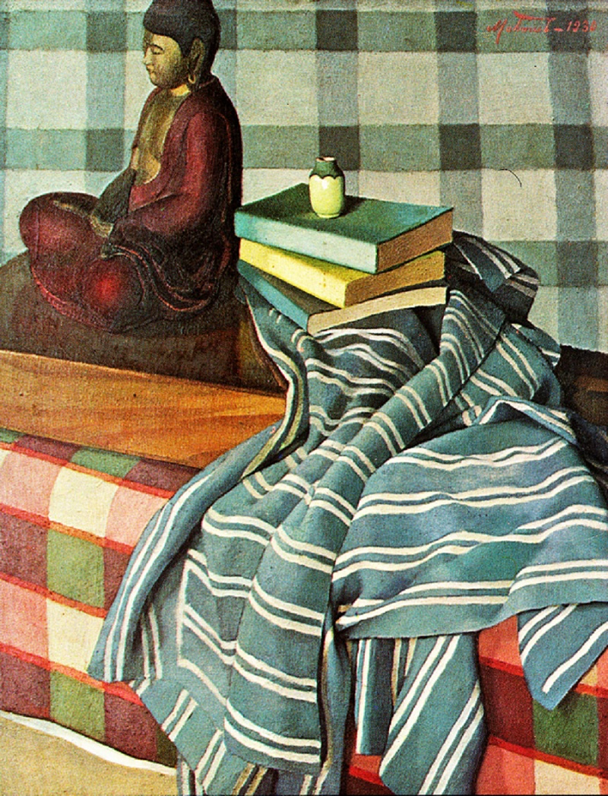

Mahmud Cuda. *Still-Life.* 1930. Oil on Canvas, 72 x 56 cm. Mimar Sinan Güzel Sanatlar Üniversitesi (MSGSÜ) Istanbul Museum of Painting and Sculpture.

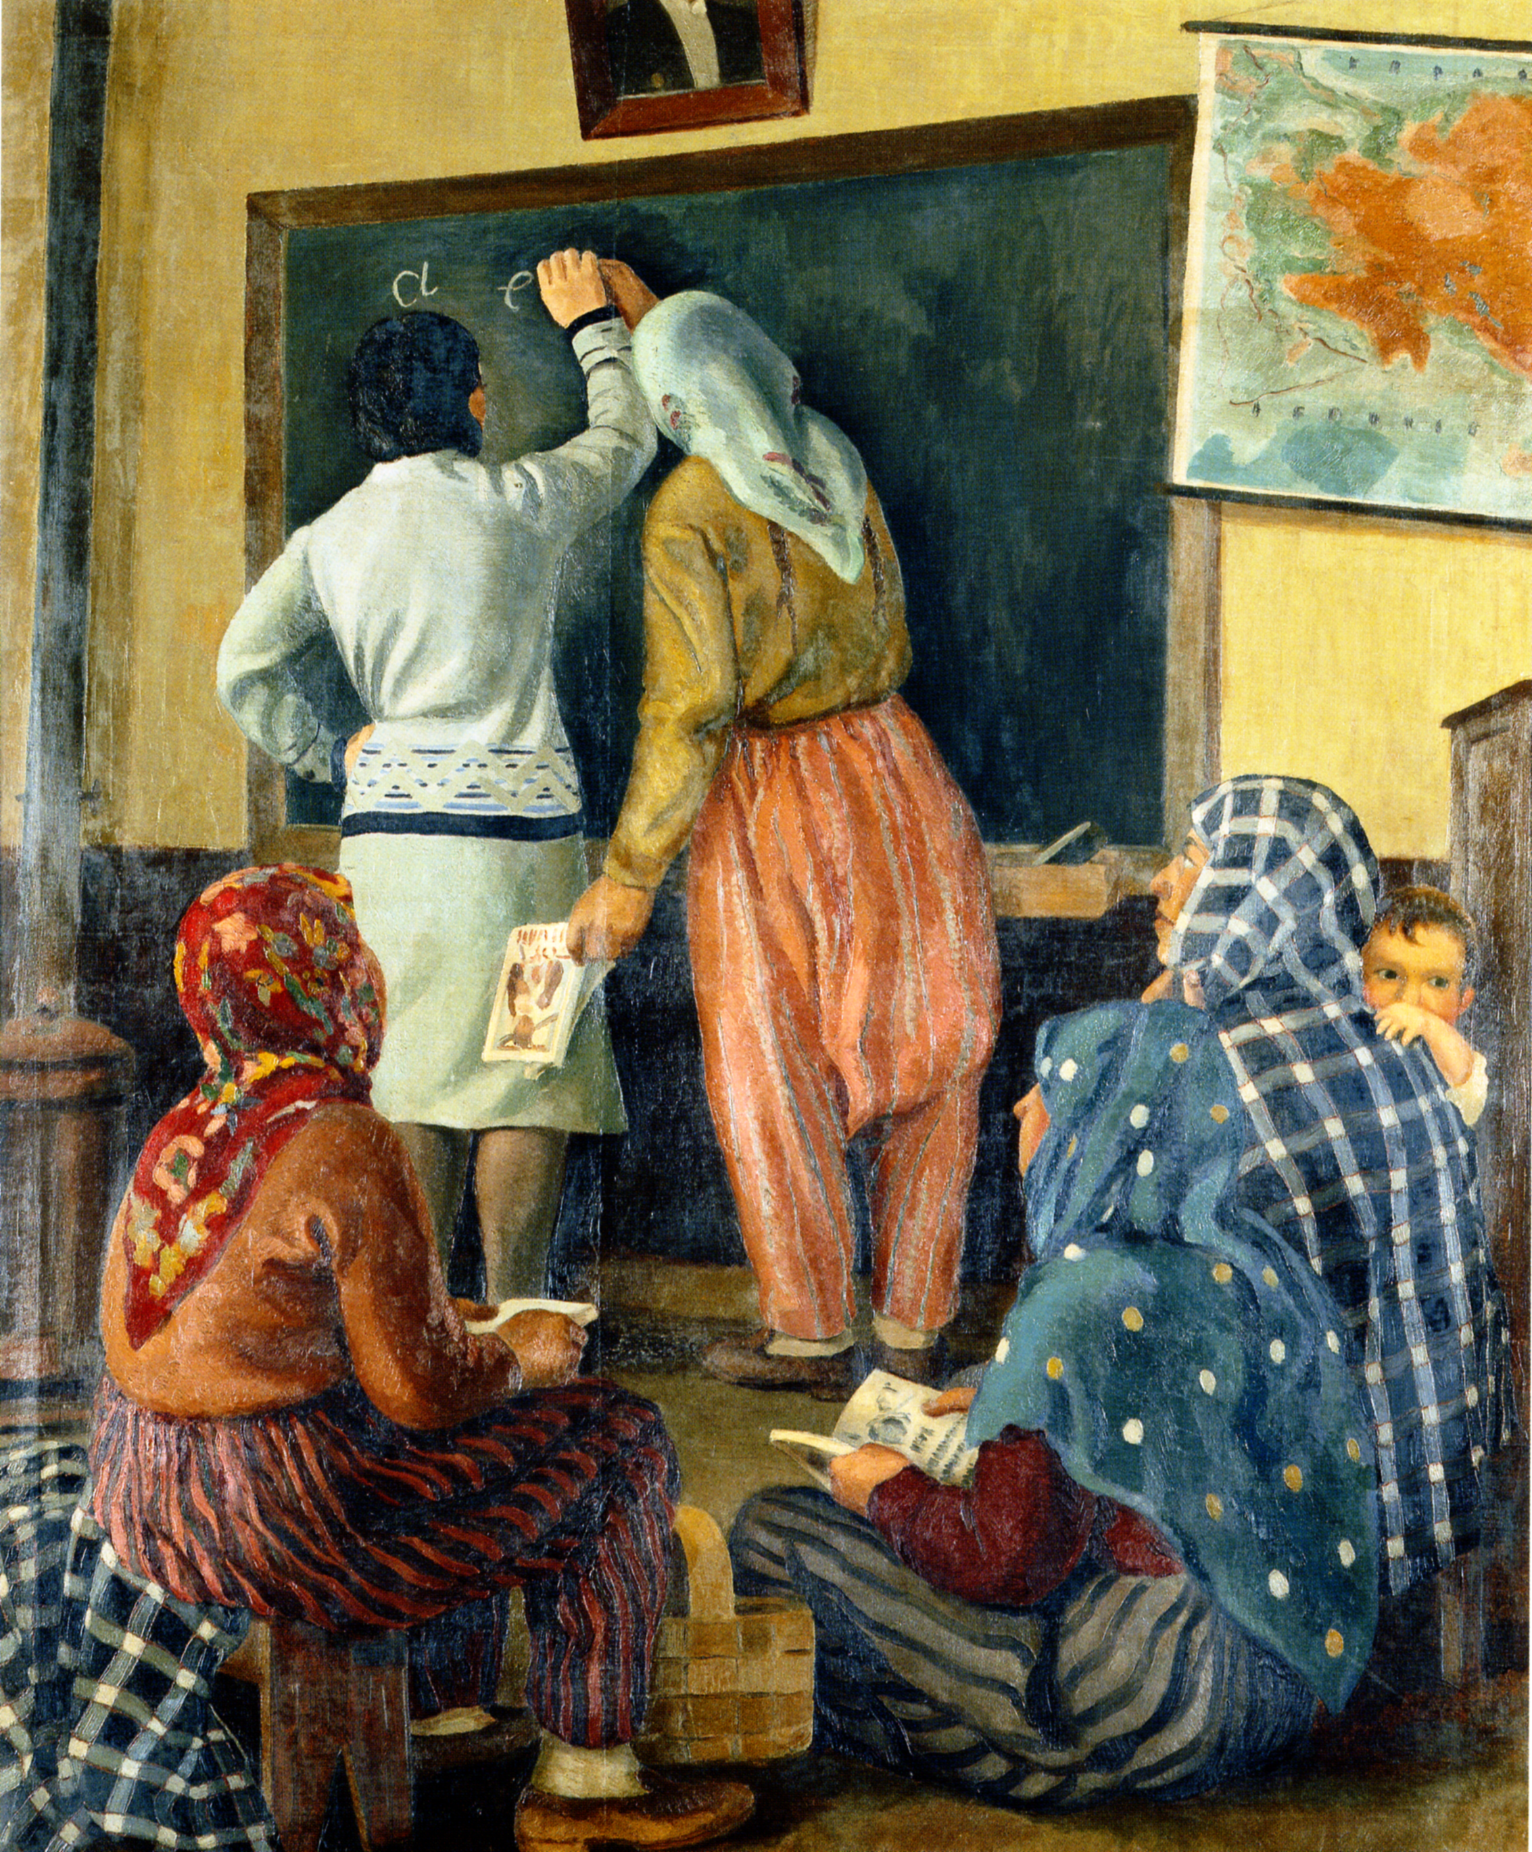

Şeref Akdik. *Literacy Course.* 1933. Oil on Canvas, 180 x 150 cm. Mimar Sinan Güzel Sanatlar Üniversitesi (MSGSÜ) Istanbul Museum of Painting and Sculpture.

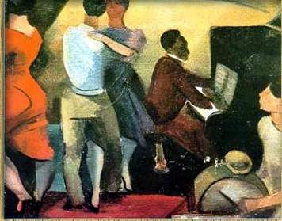

Refik Epikman. *Bar*. 1930?. Oil on Canvas, 46 x 55 cm. Mimar Sinan Güzel Sanatlar Üniversitesi (MSGSÜ) Istanbul Museum of Painting and Sculpture.

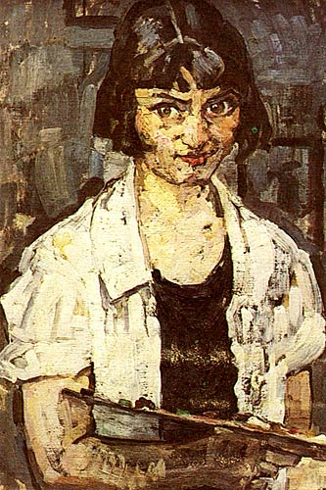

Hale Asaf. *Self-portrait.* 1925. Oil on canvas, 60 x 50 cm. Istanbul University Feyhaman Duran Culture and Art Center.

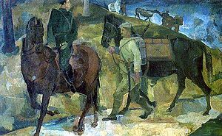

Ahmet Zeki Kocamemi. *Beasts of Burden*. 1935. 123.5 x 195.5 cm. Mimar Sinan Güzel Sanatlar Üniversitesi (MSGSÜ) Istanbul Museum of Painting and Sculpture.

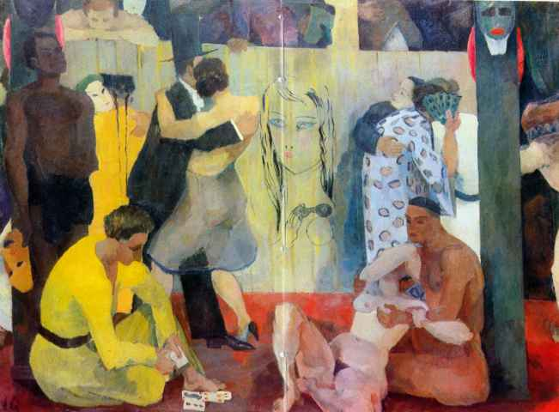

Ali Avni Çelebi. Masked Ball, 1928. Oil on Canvas, 140 x 187 cm. Mimar Sinan Güzel Sanatlar Üniversitesi (MSGSÜ) Istanbul Museum of Painting and Sculpture.